3rd Sunday in Lent
The Cross Reveals Our Father’s Grace
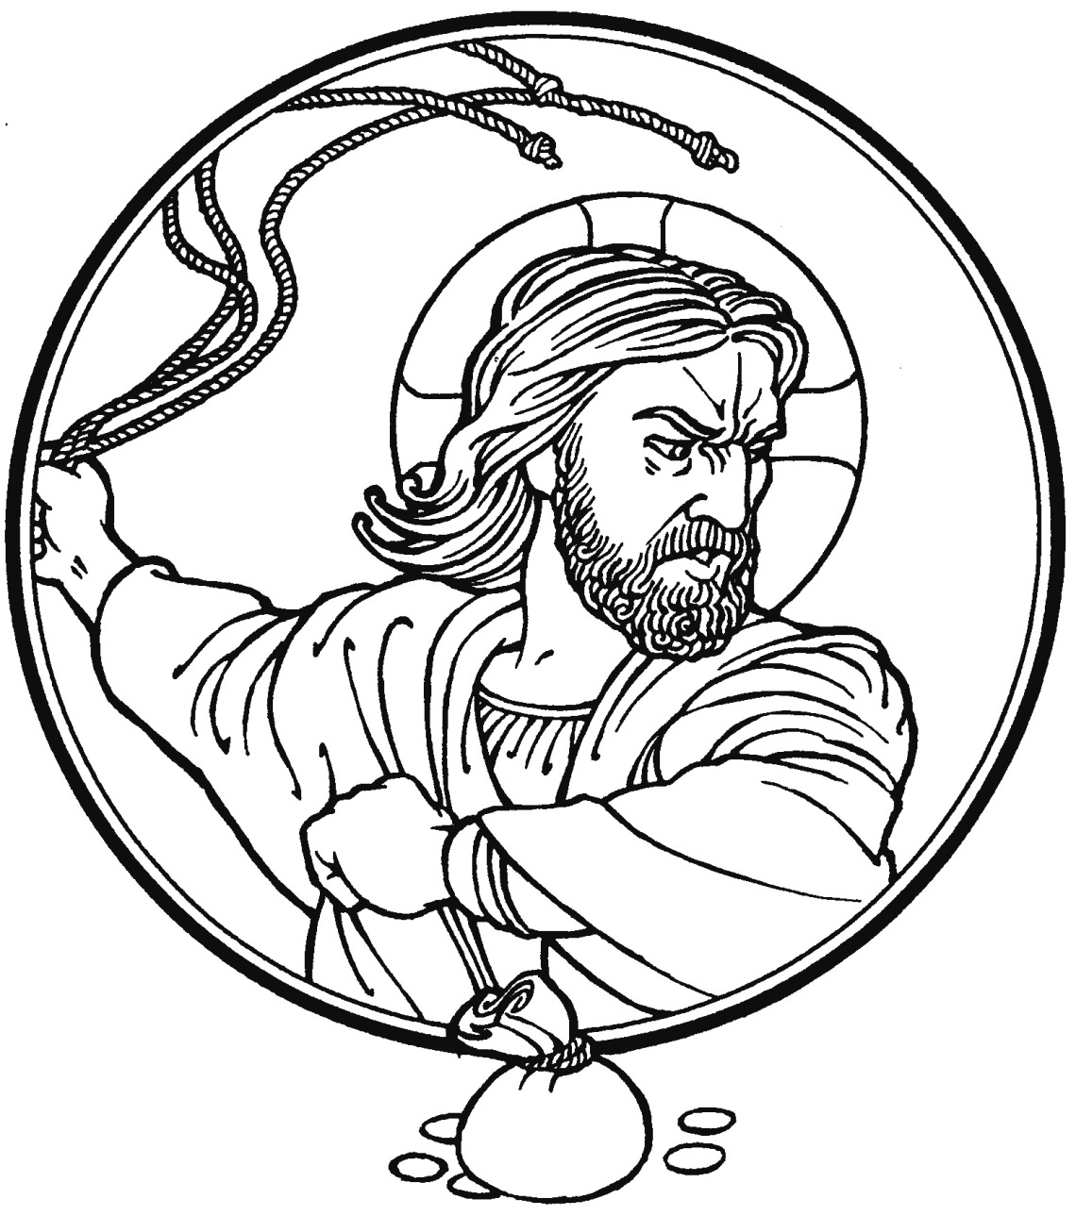
CHRIST LUTHERAN CHURCH | Lodi, California
March 7, 2021
WELCOME TO WORSHIP
Welcome to Christ Lutheran Church. We pray that your soul will be strengthened by the good news about God’s grace, love, and forgiveness given to us. If you would like to learn more about our church, please speak with our pastor or one of our members after the service.
- Bathrooms are located in the fellowship hall. A changing table is located in the women’s bathroom.
- A worship monitor is to the right as you exit. We encourage children of all ages to participate in our worship. Please bring them into the service. We have a nursery room with toys, books, and other items that you can use with your child.
- Before you leave, please sign our guest register. Located on the lectern in the entryway.

WORSHIP THEME
God’s Law is filled with comprehensive expectations. We confess and believe these holy tenets to be true, but because of sin we are powerless to keep them. Only Christ is able to satisfy the Law’s demands, and yet he is crucified; we are forgiven. His cross reveals divine power, wisdom, strength, and righteousness. Jesus endures the cross, knowing that his body would be resurrected to new life, abolishing the Law’s damning effect on those who believe in him.
Today has been known as Scrutiny Sunday because it was at this time when the church began to examine the Catechumens. Today we examine ourselves. We ask the Lord to open our eyes as we begin our spiritual spring cleaning.

Common Service

OPENING HYMN God of Grace and God of Glory | CW 523

Please stand
INVOCATION
M: In the name of the Father and of the Son and of the Holy Spirit.
C: Amen.

CONFESSION OF SINS
M: Beloved in the Lord: let us draw near with a true heart and confess our sins to God our Father, asking him in the name of our Lord Jesus Christ to grant us forgiveness.
C: Holy and merciful Father, I confess that I am by nature sinful, and that I have disobeyed you in my thoughts, words, and actions. I have done what is evil and failed to do what is good. For this I deserve your punishment both now and in eternity. But I am truly sorry for my sins, and trusting in my Savior Jesus Christ, I pray: Lord, have mercy on me, a sinner.
LORD, HAVE MERCY – Kyrie
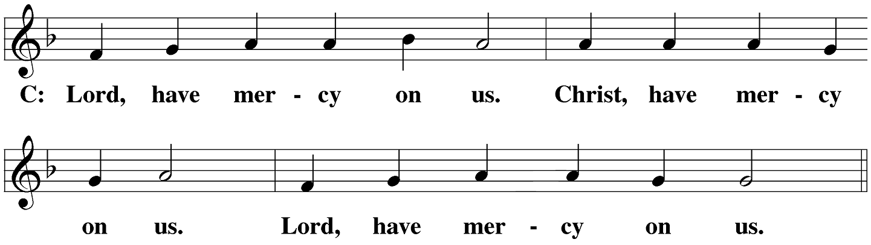

absolution
M: God, our heavenly Father, has been merciful to us and has given his only Son to be the atoning sacrifice for our sins. Therefore, as a called servant of Christ and by his authority, I forgive you all your sins in the name of the Father and of the Son ✙ and of the Holy Spirit.
C: Amen.
PRAYER AND PRAISE
M: In the peace of forgiveness, let us praise the Lord.
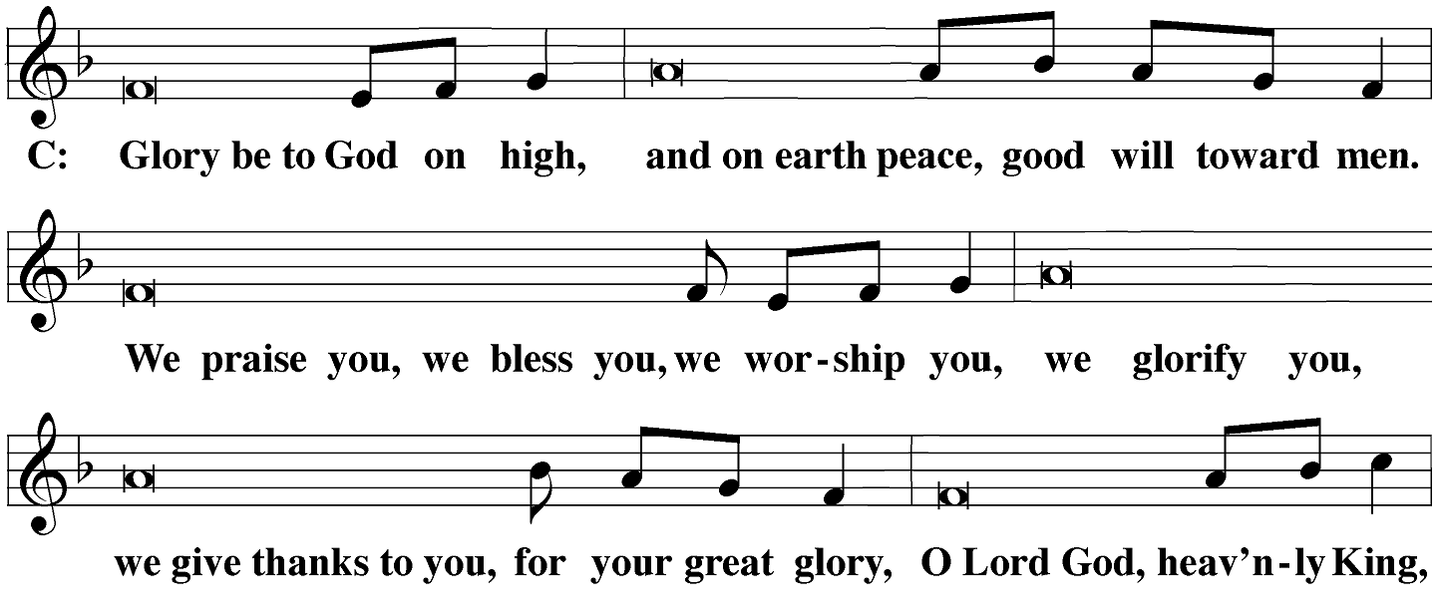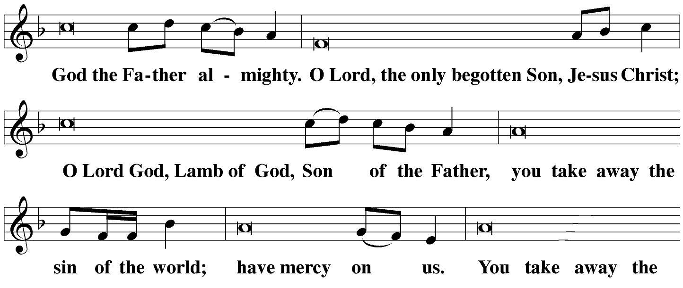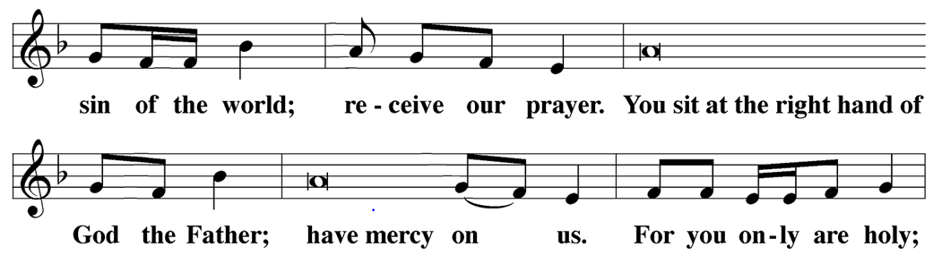
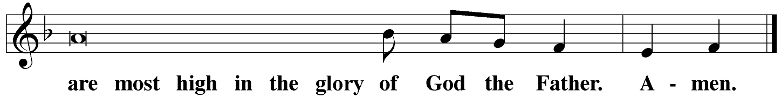
PRAYER OF THE DAY
M: The Lord be with you.
C: And also with you.
M: Let us pray.
O God, whose glory it is always to have mercy, be gracious to all who have gone astray from your ways and bring them again with penitent hearts and steadfast faith to embrace and hold fast the unchangeable truth of your Word; through Jesus Christ, your son, our Lord, who lives and reigns with you and the Holy Spirit, one Go, now and forever.
C Amen
Be seated
THE WORD
FIRST LESSON Exodus 20:1-17
The Moral Law is given not as a suggestion, encouragement, or pious wish, but as the command of our Eternal Creator and LORD.
Then God spoke all these words:
² I am the Lord your God, who brought you out of the land of Egypt, out of the place of slavery.
³ Do not have other gods besides me.
⁴ Do not make an idol for yourself, whether in the shape of anything in the heavens above or on the earth below or in the waters under the earth. ⁵ Do not bow in worship to them, and do not serve them; for I, the Lord your God, am a jealous God, bringing the consequences of the fathers’ iniquity on the children to the third and fourth generations of those who hate me, ⁶ but showing faithful love to a thousand generations of those who love me and keep my commands.
⁷ Do not misuse the name of the Lord your God, because the Lord will not leave anyone unpunished who misuses his name.
⁸ Remember the Sabbath day, to keep it holy: ⁹ You are to labor six days and do all your work, ¹⁰ but the seventh day is a Sabbath to the Lord your God. You must not do any work—you, your son or daughter, your male or female servant, your livestock, or the resident alien who is within your city gates. ¹¹ For the Lord made the heavens and the earth, the sea, and everything in them in six days; then he rested on the seventh day. Therefore the Lord blessed the Sabbath day and declared it holy.
¹² Honor your father and your mother so that you may have a long life in the land that the Lord your God is giving you.
¹³ Do not murder.
¹⁴ Do not commit adultery.
¹⁵ Do not steal.
¹⁶ Do not give false testimony against your neighbor.
¹⁷ Do not covet your neighbor’s house. Do not covet your neighbor’s wife, his male or female servant, his ox or donkey, or anything that belongs to your neighbor.

PSALM OF THE DAY Psalm 19 / CW p.70
The heavens declare the glory of God;
the skies proclaim the work of his hands.
Their voice goes out into all the earth,
their words to the ends of the world.
Refrain
The law of the LORD is perfect,
giving joy to the heart.
The commands of the LORD are radiant,
giving light to the eyes.
They are more precious than gold;
they are sweeter than honey.
By them is your servant taught;
in keeping them there is great reward.
Refrain
May the words of my mouth and the meditation of my heart
be pleasing in your sight, O LORD, my Redeemer.
Glory be to the Father and to the Son
and to the Holy Spirit,
as it was in the beginning,
is now, and will be forever. Amen.
Refrain

SECOND LESSON 1 Corinthians 1:18-31
Their eyes were closed to a suffering Savior, Jews wanted more miracles, Gentiles wanted more wisdom. They couldn’t see the dirt. They thought they were fulfilling the Law. God opens eyes to see his Son.
¹⁸ For the word of the cross is foolishness to those who are perishing, but it is the power of God to us who are being saved. ¹⁹ For it is written,
I will destroy the wisdom of the wise,
and I will set aside the intelligence of the intelligent.^{[a]}
²⁰ Where is the one who is wise? Where is the teacher of the law?^{[b]} Where is the debater of this age? Hasn’t God made the world’s wisdom foolish? ²¹ For since, in God’s wisdom, the world did not know God through wisdom, God was pleased to save those who believe through the foolishness of what is preached. ²² For the Jews ask for signs and the Greeks seek wisdom, ²³ but we preach Christ crucified, a stumbling block to the Jews and foolishness to the Gentiles.^{[c]} ²⁴ Yet to those who are called, both Jews and Greeks, Christ is the power of God and the wisdom of God, ²⁵ because God’s foolishness is wiser than human wisdom, and God’s weakness is stronger than human strength.
²⁶ Brothers and sisters, consider your calling: Not many were wise from a human perspective,^{[d]} not many powerful, not many of noble birth. ²⁷ Instead, God has chosen what is foolish in the world to shame the wise, and God has chosen what is weak in the world to shame the strong. ²⁸ God has chosen what is insignificant and despised in the world—what is viewed as nothing—to bring to nothing what is viewed as something, ²⁹ so that no one^{[e]} may boast in his presence. ³⁰ It is from him that you are in Christ Jesus, who became wisdom from God for us—our righteousness, sanctification, and redemption— ³¹ in order that, as it is written: Let the one who boasts, boast in the Lord.^{[f]}
VERSE OF THE DAY John 3:14-15
Just as Moses lifted up the snake in the desert, so the Son of Man must
be lifted up, that everyone who believes in Him may have eternal life.
Stand
THE GOSPEL John 2:13-25
Jesus cleans his house. This is a mess made by the stewards but Jesus doesn’t use the usual tools to clean. He makes a whip and then he goes for the sledgehammer.
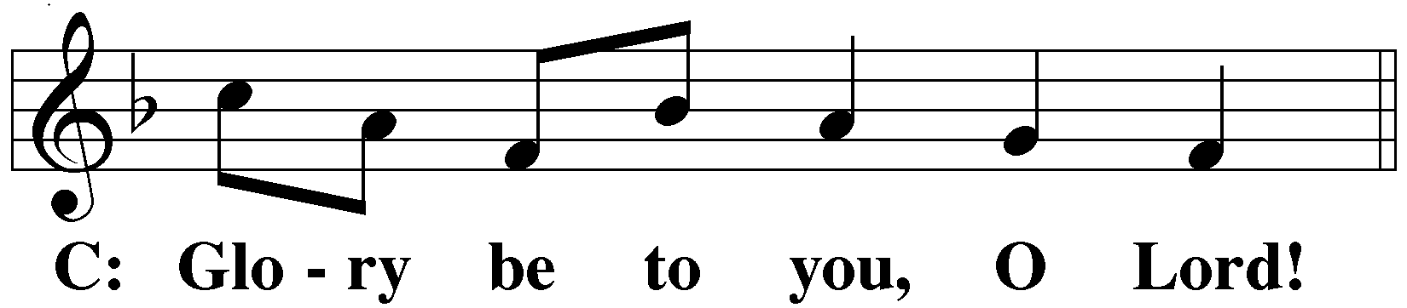
¹³ The Jewish Passover was near, and so Jesus went up to Jerusalem. ¹⁴ In the temple he found people selling oxen, sheep, and doves, and he also found the money changers sitting there. ¹⁵ After making a whip out of cords, he drove everyone out of the temple with their sheep and oxen. He also poured out the money changers’ coins and overturned the tables. ¹⁶ He told those who were selling doves, “Get these things out of here! Stop turning my Father’s house into a marketplace!”^{[a]}
¹⁷ And his disciples remembered that it is written: Zeal for your house will consume me.^{[b]}
¹⁸ So the Jews replied to him, “What sign will you show us for doing these things?”
¹⁹ Jesus answered, “Destroy this temple,^{[c]} and I will raise it up in three days.”
²⁰ Therefore the Jews said, “This temple took forty-six years to build,^{[d]} and will you raise it up in three days?”
²¹ But he was speaking about the temple of his body. ²² So when he was raised from the dead, his disciples remembered that he had said this, and they believed the Scripture and the statement Jesus had made.
²³ While he was in Jerusalem during the Passover Festival, many believed in his name when they saw the signs he was doing. ²⁴ Jesus, however, would not entrust himself to them, since he knew them all ²⁵ and because he did not need anyone to testify about man; for he himself knew what was in man.

M This is the Gospel of the Lord.
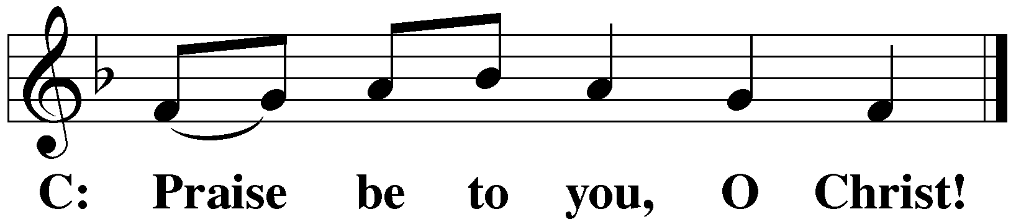

NICENE CREED
Stand
We believe in one God, the Father, the Almighty, maker of heaven and earth, of all that is, seen and unseen.
We believe in one Lord, Jesus Christ, the only Son of God, eternally begotten of the Father, God from God, Light from Light, true God from true God, begotten, not made, of one being with the Father. Through him all things were made. For us and for our salvation, he came down from heaven, was incarnate of the Holy Spirit and the virgin Mary, and became fully human. For our sake he was crucified under Pontius Pilate. He suffered death and was buried. On the third day he rose again in accordance with the Scriptures. He ascended into heaven and is seated at the right hand of the Father. He will come again in glory to judge the living and the dead, and his kingdom will have no end.
We believe in the Holy Spirit, the Lord, the giver of life, who proceeds from the Father and the Son, who in unity with the Father and the Son is worshiped and glorified, who has spoken through the prophets. We believe in one holy Christian and apostolic Church. We acknowledge one baptism for the forgiveness of sins. We look for the resurrection of the dead and the life of the world to come. Amen.
Be seated
HYMN OF THE DAY May God Bestow on Us His Grace | CW 574

SERMON John 2:13-25
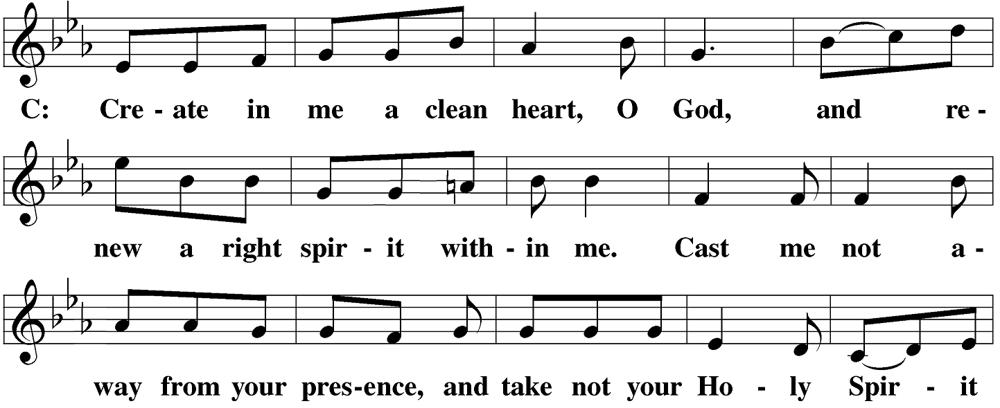
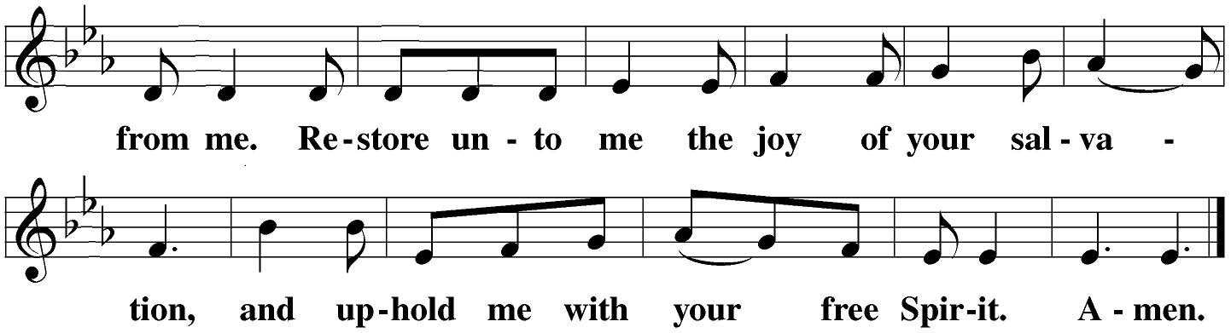
Be seated
OFFERING
The offerings of the members of Christ Lutheran are gathered at this time. Guests need not feel obligated to give an offering.
PRAYER OF THE CHURCH
Stand
M: Heavenly Father, you loved the world and gave your Son to liberate us from sin and death by his obedient death on the cross.
C: We confess that without your love we are lost.
M: Lord of the Church, we thank you for the treasure of the gospel. By your Spirit, keep our eyes fixed on Jesus, the author and perfecter of our faith.
C: Strengthen our determination to do what pleases you, no matter what the danger or the cost.
M: Let us pray for those who carry a cross in the name of Christ and face ridicule and persecution for the sake of the kingdom: missionaries and chaplains, young people who stand up for what is right in the face of pressure to do what is wrong, and all who pay a high price for their faith and their values as Christians.
C: By your Spirit, O Lord, grant them patience and endurance.
M: Let us pray for those who carry heavy burdens in life: the sick and the chronically ill, the depressed and the lonely, those torn by conflict in personal relationships, those victimized by war and injustice, and all who face the terrors of life with a heavy heart.
C: Grant them peace, O Lord, and in your mercy, be their guardian and friend, their comfort and hope.
M: Let us pray for those who care for others: pastors and counselors; physicians and nurses; social workers and caring friends; all who feed the hungry, comfort the hurting, and stand beside the dying.
C: Strengthen them in their work, O Lord, and do not let them become weary in doing good.
Special prayers and intercessions.
M: Hear us, Lord, as we bring you our private petitions.
Silent Prayer.
M: Help us run with perseverance the race marked out for us. Keep us faithful even to the point of death, that we may receive the crown of life, through Jesus Christ, our Lord.
C: Amen.
LORD’S PRAYER
Our Father, who art in heaven,
hallowed be thy name.
Thy kingdom come.
Thy will be done,
on earth as it is in heaven.
Give us this day our daily bread;
and forgive us our trespasses,
as we forgive those
who trespass against us;
and lead us not into temptation,
but deliver us from evil.
For thine is the kingdom
and the power and the glory
forever and ever. Amen.
THE SACRAMENT
PREFACE
M The Lord be with you.
C And also with you.
M Lift up your hearts.
C We lift them up to the Lord.
M Let us give thanks to the Lord our God.
C It is good and right so to do.
M It is truly good and right that we should at all times and in all places give you thanks, O Lord, holy father, almighty and everlasting God, through Jesus Christ, our Lord,
who brought the gift of salvation to all people by his death on the tree of the cross, so that the devil, who overcame us by a tree would in turn by a tree be overcome.
Therefore, with all the saints on earth and hosts of heaven, we praise your holy name and join their glorious song:
HOLY, HOLY, HOLY Sanctus – sanctus means “holy.” Used as early as the second century, this canticle was in wide use among Christians by the fourteenth century.
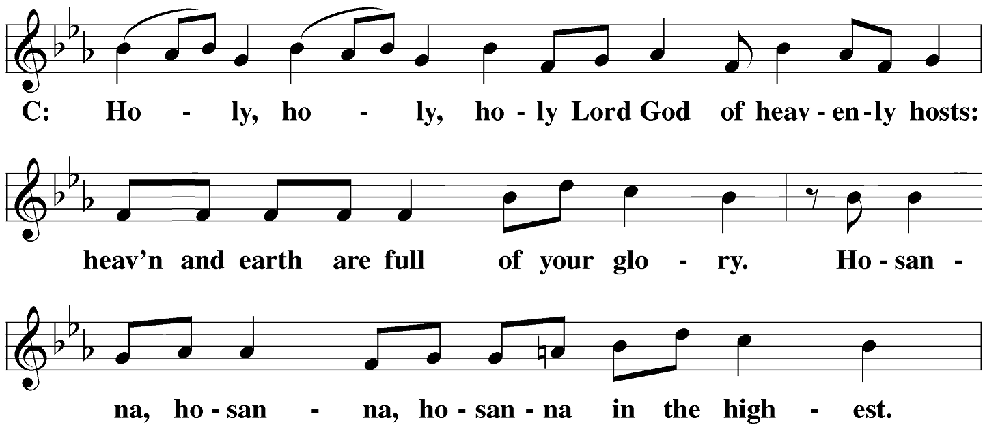
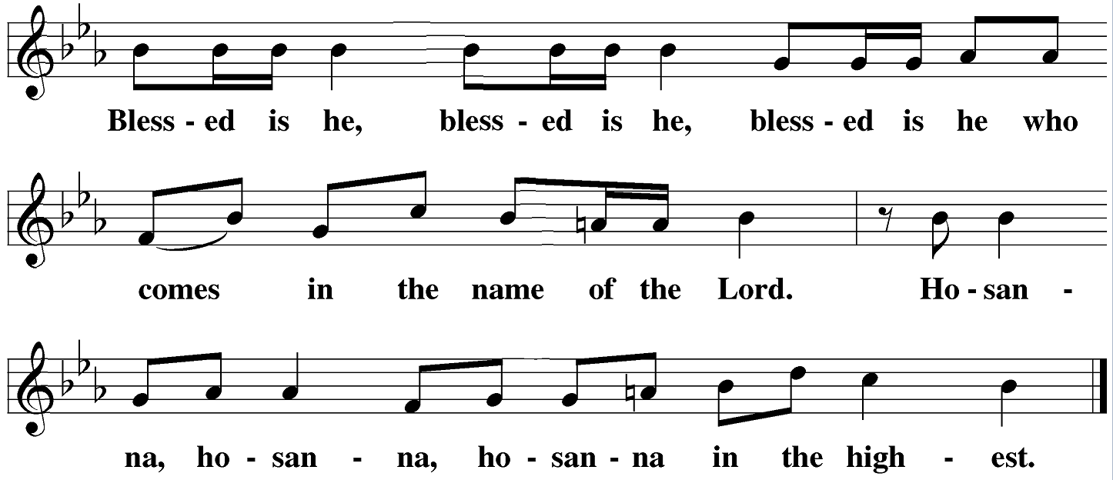

WORDS OF INSTITUTION - The Words of institution both proclaim the words of Jesus to the congregation and sets apart the bread and wine for the Lord’s Supper.
M Our Lord Jesus Christ, on the night he was betrayed, took bread; and when he had given thanks, he broke it and gave it to his disciples, saying: “Take and eat. This is my ✙ body, which is given for you. Do this in remembrance of me.”
Then he took the cup, gave thanks, and gave it to them, saying, “Drink from it all of you; this is my ✙ blood of the new covenant, which is poured out for you for the forgiveness of sins. Do this, whenever you drink it, in remembrance of me.”
The peace of the Lord be with you always.
C Amen.
O CHRIST, LAMB OF GOD – Agnus Dei
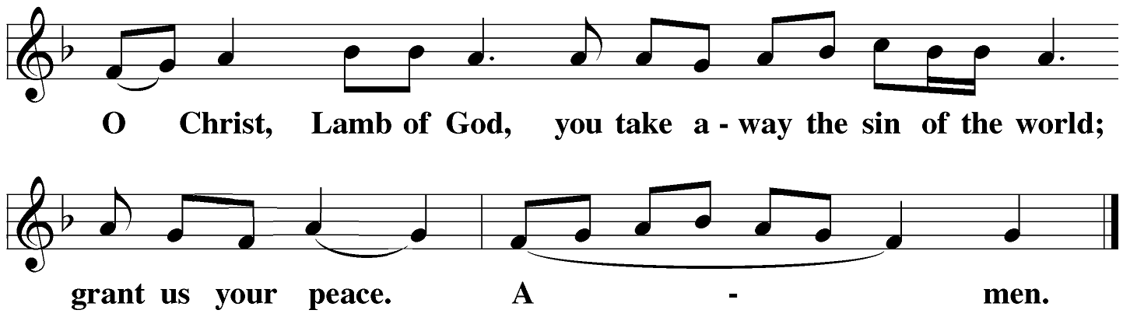
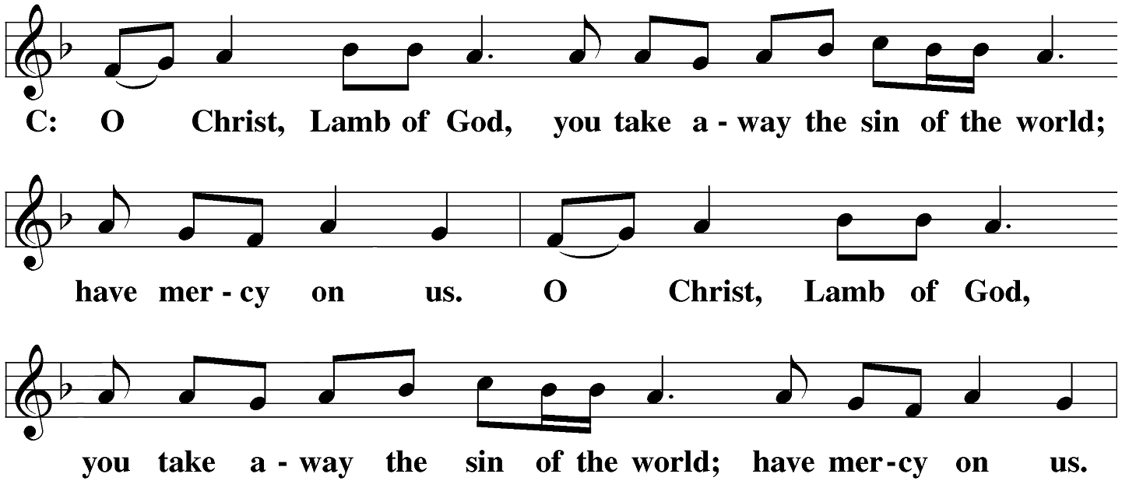

Be seated

DISTRIBUTION
Participation in the Sacrament is an expression of a common faith. Our guests today who are not members of a congregation in the Wisconsin Evangelical Lutheran Synod (or a church in fellowship with the WELS) are invited to speak with the pastor to learn how you might receive the sacrament with us in the future.

THANKSGIVING
Stand
SONG OF SIMEON – Nunc Dimittis
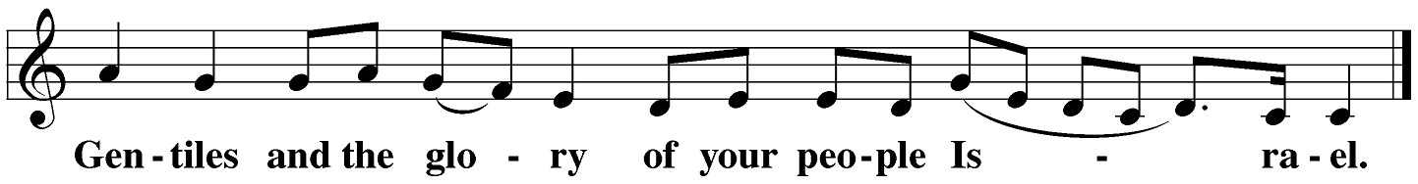
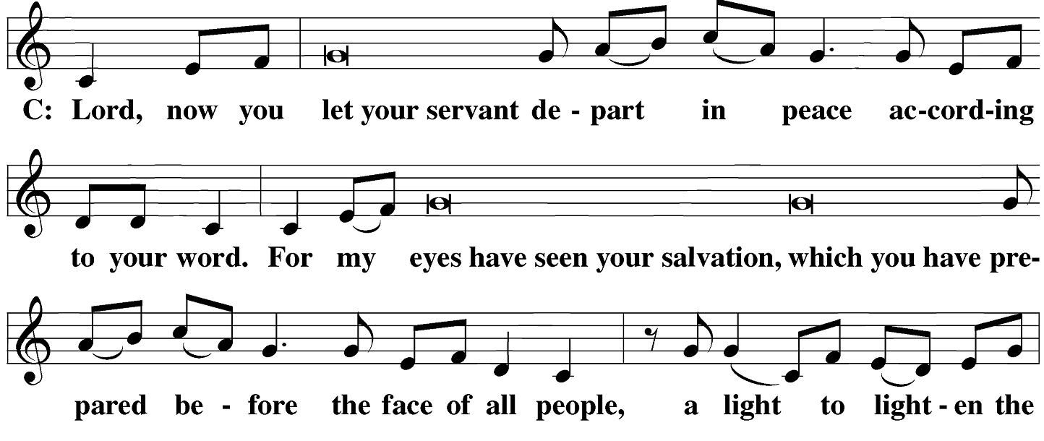

M: O give thanks to the Lord, for he is good.
C: And his mercy endures forever.
M: We give thanks, almighty God, that you have refreshed us with this holy supper. We pray that through it you will strengthen our faith in you and increase our love for one another. We ask this in the name of Jesus Christ, our Lord, who lives and reigns with you and the Holy Spirit, one God, now and forever.
C: Amen.

THE BLESSING
M The Lord bless you and keep you.
The Lord make his face shine on you and be gracious to you.
The Lord look on you with favor and ✙ give you peace.
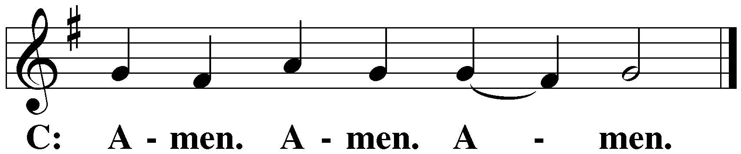
Be seated

CLOSING HYMN How Firm a Foundation | CW 416

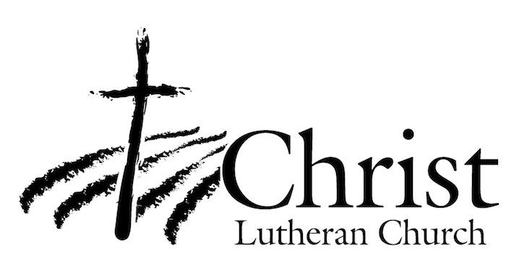
13009 N. Elderberry Ct.
Lodi, CA 95242
www.christlodi.org
209-368-6250
Pastor Joshua Hanson
WELCOME TO CHRIST EV. LUTHERAN CHURCH!
We preach a message of forgiveness, hope and peace
through the death and resurrection of Jesus Christ.
Families and individuals of all ages will find opportunities
both to grow and to serve.
Our mission statement:
Look what Christ is doing!
He binds us together in fellowship
He gathers us in for worship
He builds us up for service
He sends us out with the gospel

“Now you are the body of Christ,
and each one of you is a part of it.”
(1 Corinthians 12:27)
COPYRIGHT INFORMATION
Content requiring a copyright license is reproduced under OneLicense.net #A-718312. All rights reserved. The Common Service: Texts revised from The Lutheran Hymnal, 1941. Music revised by James Engel. Scripture Quotations: From the Holy Bible, New International Version (NIV 1984), © 1973, 1978, 1984 by Biblica, Inc.

